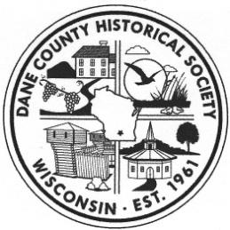
Dane County Historical Society
Lussier Family Heritage Center, 3101 Lake Farm Road, Madison, WI 53711
(608) 224-3605 danecountyhistory@gmail.com

2021 Annual Meeting
Minutes

- Welcome from John Decker, President

- Board member election.
John Decker, Jane Licht and Barbara Furstenberg were each re-elected for new three terms ending in 2024.

- Award presented by Barbara Furstenberg, DCHS Secretary, to Karen Baumann, for her dedication as a multi-year volunteer in maintaining the Otto Schroeder Archives and Records Center.

- Revised by-laws unanimously approved by the membership.

- Unveiling of new DCHS Marker for the Lewis Nine Springs E-Way with a presentation by Andy Lewis, son of Philip and Elizabeth Lewis.

- Presentation by Danielle Benden, Driftless Pathways about the Lunney Lake Farm Park Interpretative Plan currently underway.

